Configuration Management — Moderated LMS

1. Version Control
The project uses Git for source-code version control and GitHub for remote repository hosting.
Repository: https://github.com/Letsae/CS4430-Implementation

2. Branching Strategy
The project follows a feature-branch workflow:
- main: stable, tested code.
- feature/<name>: development of individual features.
- fix/<name>: correction of defects.
- docs/<name>: documentation changes.
Changes are developed on separate branches and merged into main through pull requests after review and testing.

3. Commit Strategy
Commits use descriptive messages that explain the purpose of each change.
Examples:
- feat: implement submission audit logging
- fix: correct late penalty calculation
- test: add moderation integration tests
- docs: add manual testing instructions

4. Continuous Integration
GitHub Actions automatically builds the project and runs automated tests when changes are pushed or pull requests are opened.
The pipeline performs:
- CMake configuration.
- Project compilation.
- Automated GoogleTest execution.
- Test result reporting.
- Coverage reporting where configured.

5. Release Management
Stable versions are identified using Git tags.
Example release tag: v1.0.0
A release is created after the project builds successfully and the automated tests pass.

6. Configuration Management Evidence
Evidence includes:
- GitHub repository and commit history.
- Feature branches and pull requests.
- GitHub Actions workflow and successful CI runs.
- Release tags.

Meaningful commits
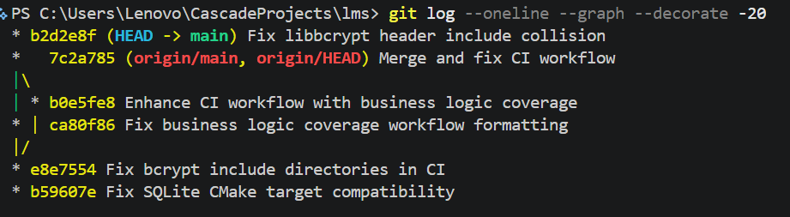

Verify CI pipeline
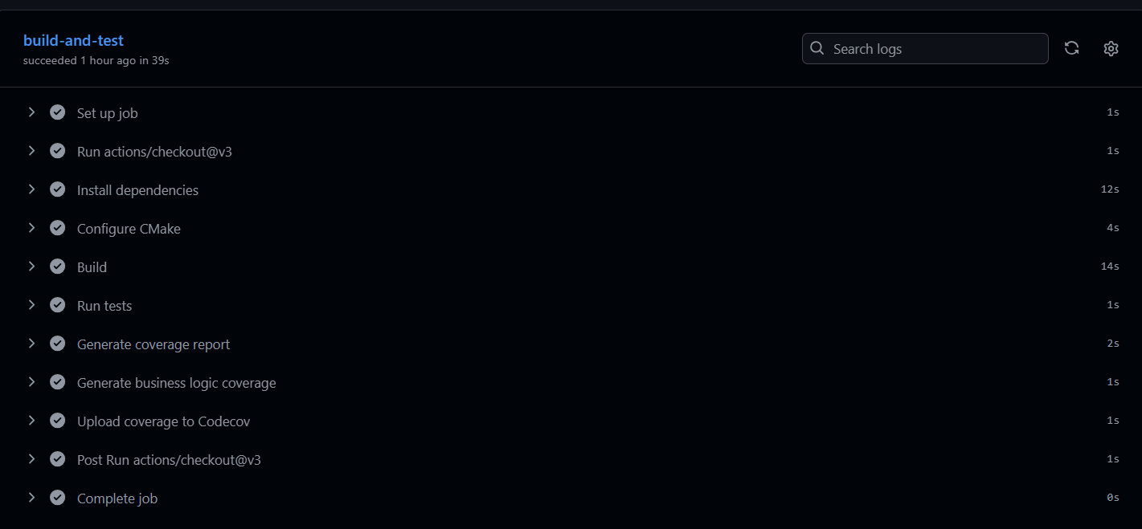

Metrics & code review


